**BUSINESS REQUIREMENT DOCUMENT (BRD)**

Kolli Meghana (EmpId:- 284717) , Garikapati Kausthub Rao (EmpId:- 284748)

August 2024

**Scope:**

1. **Functional Requirements**
2. **Assignment Management:**

Teachers have the ability to upload assignments directly to the platform, making it easy for them to distribute tasks to students. They can also set deadlines for these assignments, ensuring that students are aware of the time frames they have to complete their work. This feature streamlines the assignment distribution process and helps maintain an organized and structured learning environment.

1. **Result Metrics:**

Students can view their scores for individual assignments, all combined in a single bar graph, providing a clear overview of their performance within a course. However, to compare their scores across different tasks, they will need to navigate to the specific course section. This design ensures that students can easily monitor their progress while maintaining focus on individual courses

**3) Resource Support:**

The platform offers comprehensive resource support, where teachers can upload and provide essential study materials directly to students. These materials can include lecture notes, reading lists, practice exercises, and supplementary content, all carefully curated to enhance the learning experience.

**4) Notes Section:**

A notes section is provided allowing students to jot down important information or reminders. This feature ensures that students can take notes no matter where they are on the platform, keeping their thoughts organized and accessible. The notes section will be same for every page they are navigating inside the application, it can be considered as central notes section

**5) AI Tutor:**

The main problem for the students is that they cannot freely interact and ask their doubts to the teacher. The student might not get a clear and proper clarity on the topic explained. The personal ai tutor will take query from the student and the ai tutor will give the answer to the student.

1. **Non-Functional Requirements**
2. **Usability:**

The platform is designed with a strong focus on usability, ensuring that the interface is intuitive and user-friendly. This approach makes it easy for both students and teachers to navigate the platform, whether they are tech-savvy or not. The application is optimized for both desktop and mobile devices, allowing users to access their coursework and resources from anywhere, at any time. Consistent and straightforward navigation throughout the platform ensures that users can easily find what they need without getting lost or confused, creating a seamless and efficient learning experience.

1. **Performance:**

Performance is a top priority, with the platform engineered to deliver quick loading times and responsive interactions, even when a large number of users are active simultaneously. Whether during peak times like assignment deadlines or regular daily use, the platform remains fast and efficient, ensuring a smooth experience for all users. This focus on performance helps maintain user satisfaction and prevents frustration, particularly in time-sensitive situations.

1. **Reliability:**

The platform is built to be highly reliable, with a focus on ensuring maximum availability and uptime, especially during critical periods like exams or assignment submissions. Robust infrastructure and regular maintenance work together to minimize downtime, providing students and teachers with a dependable learning environment. This reliability is crucial for maintaining trust and confidence in the platform, particularly when users are relying on it for important academic tasks.

1. **Scalability:**

Scalability is a key consideration in the platform's design, allowing it to grow alongside the needs of its users. The system is capable of handling an increasing number of users, resources, and data without compromising performance. It supports both horizontal and vertical scaling, making it adaptable to growing demands over time. Whether accommodating a sudden influx of new users or expanding to include additional features, the platform remains flexible and responsive to change.

1. **Interoperability:**

The platform is designed with interoperability in mind, ensuring compatibility with various operating systems and browsers. It supports multiple languages and regional settings, making it accessible to a diverse user base from different backgrounds and locations. Additionally, the platform facilitates easy integration with other educational tools and platforms, allowing for a cohesive and connected learning experience. This interoperability enhances the platform's usability and ensures it can meet the varied needs of its users.

**TECH STACK: -**

1. **Front End**

* HTML
* CSS
* JavaScript
* TypeScript
* Angular

1. **Back End**

* Java
* Spring Boot

1. **Database**

* MySQL

**Microservices Architecture: -**

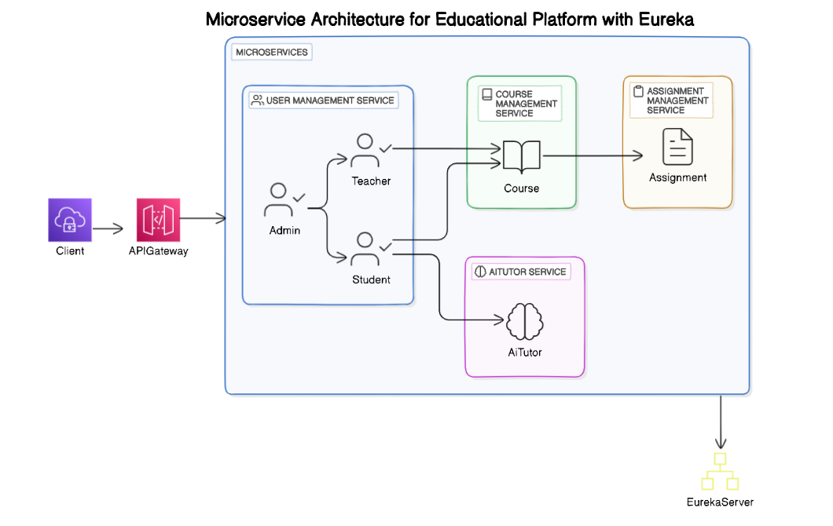

**High Level Design: -**

**Use Case Diagram: -**

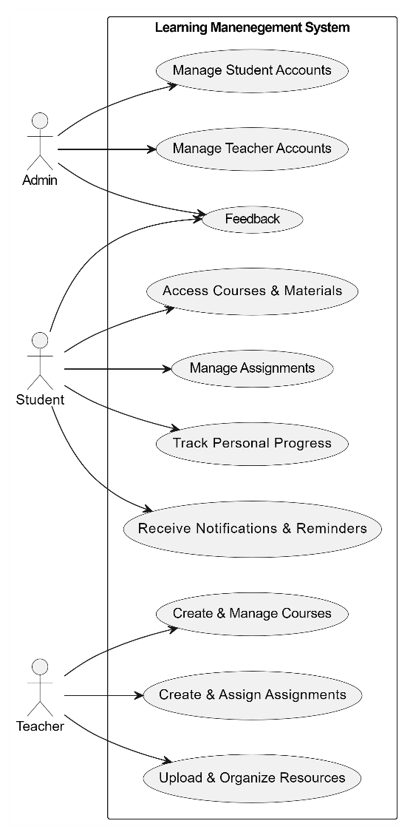

**Sequence Diagram: -**

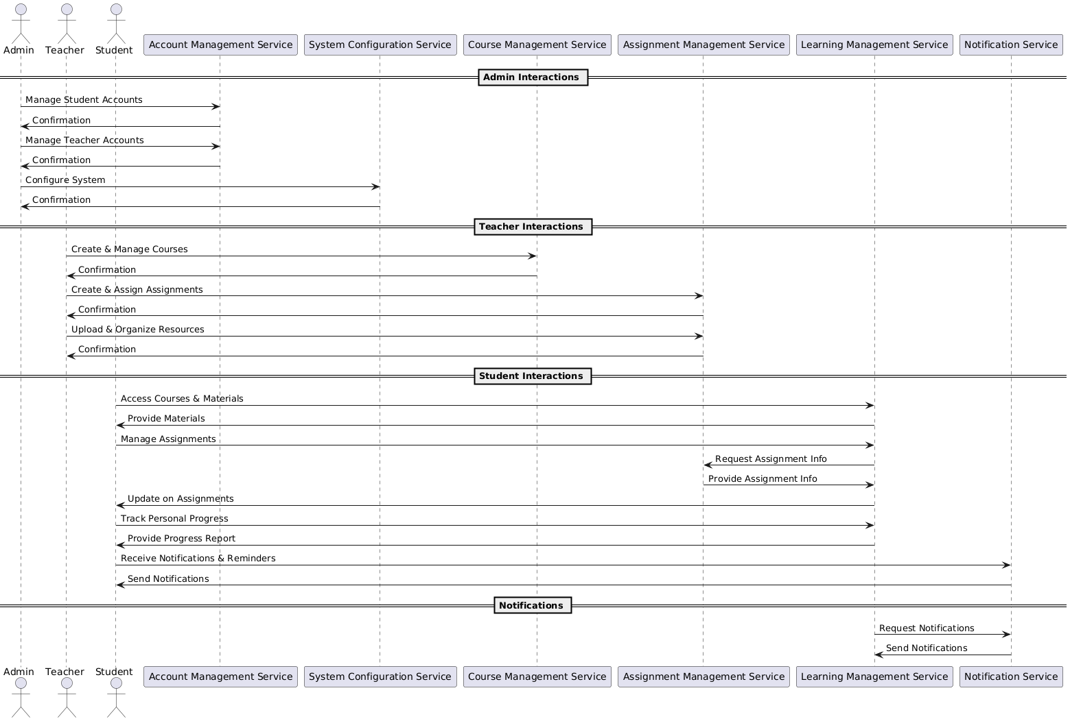

**Low Level Design: -**

**Class Diagram**

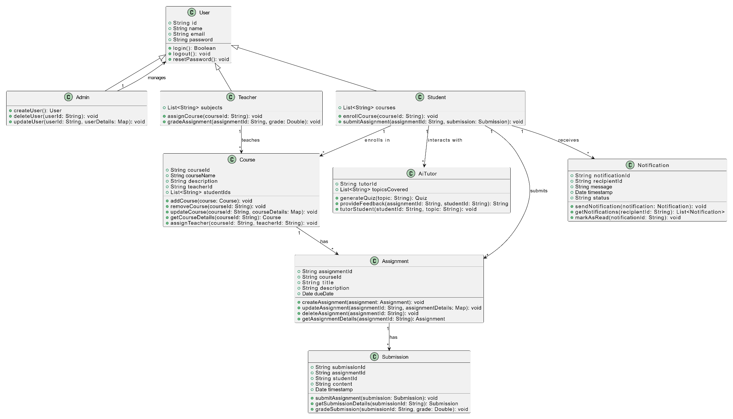

**Database Diagram: -**

